Lecture 1 Notes: Introduction to Software Project Management

What is Management?
Management is the process of getting things done efficiently. It includes: Planning – deciding what needs to be done. Organizing – arranging resources. Staffing – selecting the right people. Directing – giving instructions. Monitoring – checking progress. Controlling – fixing problems. Innovating – finding new solutions. Representing – communicating with users and stakeholders

What is a Project?
A project is an activity with specific goals, done within a limited time period.

Examples of projects: Changing company structure, staff, or workflow. Developing or purchasing a new information system. Constructing a building. Running a political campaign. Implementing new business procedures

What is Software?
Software includes programs, procedures, documentation, and data needed for operating a computer system.
According to IEEE/ISO, software has 4 components: Computer programs (code), Procedures, Documentation, Data needed for operation

What is Project Management?
Project Management is applying knowledge, skills, tools, and techniques to complete project activities and meet project requirements. Project Management Processes:
- Initiating – project selection, funding, and launch
- Planning – deciding how the work will be done
- Executing – performing the planned work
- Monitoring & Controlling – checking progress and making corrections
- Closing – completing work and finalizing the project

Differentiating Factors of Software Projects
Software projects are different because: Software is intangible. Development is human-based, requiring document sharing. Requirements usually have high uncertainty. Communication is often unclear. Intellectual ability of developers is the main asset. Initial planning is difficult due to changing requirements. Full testing is impossible due to complexity. Software security is a major challenge. Measuring software quality objectively is hard

Software Development Project: Based on customer requirements. Designing the software. Writing code. Testing to ensure it is defect-free

Software Maintenance Project: Modifying existing software. Fixing bugs. Adding new features. Porting to other operating systems
Together, these are called Software Projects.

What is an IT Project?
IT involves hardware, software, networks, storage, and processes to manage electronic data.
Example: A bank ATM system → hardware + software + communication system + user interaction.

What is Software Project Management?
Software Project Management means using project management methods plus software engineering practices to develop or maintain software with: Minimum cost, Minimum resources Minimum time
Just like a civil project needs a civil engineer, a software project must be managed by someone with software engineering knowledge. Includes both:
- Project management processes → initiation, planning, monitoring, closing
- Software engineering processes → requirements, design, coding, testing, maintenance

Operations = daily, repetitive activities. Project = temporary activity to create a unique product or result
Example: Creating a new product → Project. Continuous production of that product → Operation

10. Why Software Project Management is Special
Software development is unique because: It is unusual ("weird") and requires specialized skills. It is difficult.It can become routine and boring. Writing code can create unexpected challenges

Project Management Framework (PMI): PMI defines 10 Knowledge Areas used in project management:
- Project Integration Management: Coordinates all processes and activities.
- Project Scope Management: Ensures all required work is included—nothing extra.
- Project Time Management: Ensures project is completed on time.
- Project Cost Management: Deals with budgeting, financing, and controlling project costs.
- Project Quality Management: Ensures the project meets required quality.
- Project Human Resource Management: Organizes, manages, and leads the project team.
- Project Communications Management: Handles creation, distribution, storage, and retrieval of information.
- Project Risk Management: Identifies, analyzes, and controls risks.
- Project Procurement Management: Deals with purchasing products and services from outside. Includes planning, solicitation, source selection, contracts, and closeout.
- Project Stakeholder Management: Identifies stakeholders and manages their expectations.
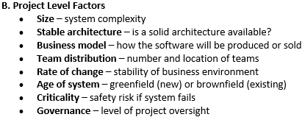

Factors Used to Differentiate Projects

A. Organization Level Factors
- Business domain – field for which the software is made
- Number of instances – how many deployments
- Organizational maturity – process maturity
- Innovation level – how innovative the company is
- Culture – working environment

Types of Software Projects
- Bespoke Software: Custom-built for one customer. Customer pays full cost. Examples: Luggage tracking system, Custom compiler, Truck fleet monitoring system. Requirements are agreed with the customer
- Off-the-Shelf Software: Mass-produced, ready-to-use. Designed for many customers. Example: ERP systems
- Installation & Training Services: Installing software. Training users in using systems or technologies
- Process and Systems Reengineering Services: Improving organizational efficiency. Changing workflows, solving bottlenecks. May include new CRM or automation tools
- System Integration Services: Connecting different independent systems. Automating information flow. Reducing data duplication and errors

Lecture-2 Notes: Software Project Evaluation Techniques

Effective Project Manager Competencies: A project manager must show 3 types of competencies:
- Knowledge: What the project manager knows about project management.
- Performance: What the project manager can accomplish using his project management knowledge.
- Personal Skills: How the project manager behaves and manages tasks during the project.

Code of Conduct & Ethical Aspects (PMI): PMI’s Code of Conduct focuses on 4 main values:
- Responsibility: Taking ownership of the decisions you make OR fail to make and their consequences.
- Respect: Treating all assigned resources properly (people, money, reputation, environment, etc.).
- Fairness: Making decisions impartially and objectively.
- Honesty: Acting truthfully and transparently.

Four Project Dimensions (The Four P’s): These four factors strongly influence software project success:
- People: Must work in effective teams. Must be motivated. Must communicate well
- Product: Customer requirements must be clearly communicated. Requirements must be broken down into smaller parts. The team must understand what has to be developed
- Process: The chosen software engineering process must suit the people and the problem. A suitable framework, methodology, and set of tasks must be selected
- Project: The project must be organized so that the team can succeed. Includes planning, scheduling, monitoring, and execution

Dealing with Organizational Politics (Guidelines for Project Managers)
- Don’t feed the fire: Avoid joining gossip, complaints, or negativity. Don’t take sides when stakeholders try to influence you
- If you can’t say something nice, stay silent: Never speak negatively about someone behind their back. Give constructive criticism openly. Give compliments strongly and publicly
- Do stand up: Don’t agree with something wrong even if senior people say it. Use tact, logic, and honesty. Stand only when you have proof. Admit when you’re wrong to build credibility
- Protect your reputation: Deliver on promises. Avoid gossip. Treat everyone fairly. Focus on project results
- Don’t micromanage: You may have strong technical skills but your job now is to lead, not code. Let the team do the technical work. Give guidance, not micromanagement
- Play fair: Treat everyone equally regarding discipline, leave, and appreciation. Fairness earns respect and reduces politics

Project, Program & Portfolio Management
- Project: A temporary effort with a start and end date. Creates a unique product, service, or result. Part of a larger program or portfolio
- Program: A group of related projects managed together. Coordinated to achieve a larger goal
Example: A car manufacturing company: Making the entire car = Program. Making the bonnet, engine, panel, etc. = Projects. When all parts integrate → complete automobile (program output)
- Portfolio: A collection of programs, projects, and operations. Managed together to support strategic business objectives
Example: Different car designs = programs. All car designs together = portfolio

Project Selection Methods
Organizations use selection methods to choose the best project. Categories:
- Benefit Measurement Methods: These compare estimated costs and benefits of each project. Methods include: Cost Benefit Ratio (CBR). Return on Investment (ROI). Payback Period (PP). Discounted Cash Flow (PV, FV). Net Present Value (NPV). Internal Rate of Return (IRR) [Numericals in slide]

- Constrained Optimization Methods: These are used for large, complex, or technical projects that require mathematical optimization. Methods Includes: Linear Programming. Non-linear Programming. Integer Programming. Dynamic Programming. Multiple-Objective Programming

Lecture 3 – Software Project Planning

Initiating the Project: The first step in any project is called initiation. At this stage, the Project Manager (PM) must understand why the project is needed. The PM should think from the perspective of the customer (the person funding the project) and other important stakeholders. Knowing the reason behind the project helps the PM ask the right questions and stay aligned with the final goal.

Identifying the Project Purpose: First ask: Why is this project being started?. Everyone (team + stakeholders) must agree on the purpose and goals. If the team is not aligned with the purpose, the project will face problems later.

What is a Stakeholder? Stakeholders are: Individuals, groups, or organizations. Who affect, are affected by, or think they are affected by the project. They can influence decisions, activities, or outcomes. Stakeholders are NOT only the people working directly on the project. We must think deeply to identify all individuals or groups who may be impacted.

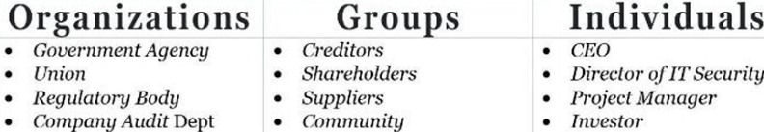
Three Stakeholder Categories: Project Managers should research and understand stakeholders.
Stakeholders can be grouped into three broad categories

Talking to the Stakeholders: Every Project Manager should ask stakeholders 5 key questions:

What are the factors for completion? You must know clearly what success looks like before starting. A project without a clear end goal is like building a house without a blueprint.

What is the goal/objective of this project? Helps the PM and the team plan the project. Goals can be improving efficiency, solving problems, gaining customers, achieving financial limits, etc. Example: Complete a move to VoIP without spending more than $235,000.

What areas of the organization will this project affect? Helps identify who needs communication. Helps reveal hidden stakeholders like security, accounting, government, training teams, etc.

What is the project priority? Projects often run in parallel. Knowing priority helps allocate time, focus, and resources.

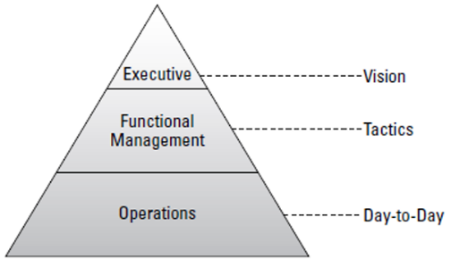
What is the accepted range of variance? Variance means how much the schedule or budget can vary (+ or –). Example: Budget = $450,000 with +45,000 or –25,000

→ Actual cost can be between $425,000 and $495,000. Same concept applies to timeline.

Levels of Organization: Different levels in an organization have different: Needs, Concerns, Goals. You must talk to each level to move the project forward.
- Talking to Executives Executives create the organization’s vision. Questions to ask them: What are the success factors? What is your vision for the project outcome? What is more important: time or budget? What risks do you expect?

Talking to Functional Management (Middle Management): Middle managers execute the executive vision. Questions to ask them: What are the success factors? Are there scheduling issues? What resources are available? Which departments/customers must coordinate? How will the project team be formed? Do you already have a budget in mind? What risks do you see?

Talking to Operations: Operations are the people who actually do the work. Questions to ask operations: What are the success factors? How will the software be used? What other projects are you working on? What immediate risks do you see? Who has the right experience? Do we need training? Which parts of the project do you dread (worry about)?

Project Charter: A Project Charter is: A short document that outlines the key goals, benefits, and purpose of the project. Helps gain support from stakeholders. Serves as a reference to keep the project on track. Describes the project before detailed planning starts

What is Project Stakeholder Management? Stakeholder management includes: Identifying all people, groups, or organizations impacting or impacted by the project. Analyzing their expectations and influence. Creating strategies to engage them effectively

Stakeholder Register: Stakeholder Register is a PMI® term used for a document that: Lists stakeholders. Includes their identification details. Shows their assessment and classification

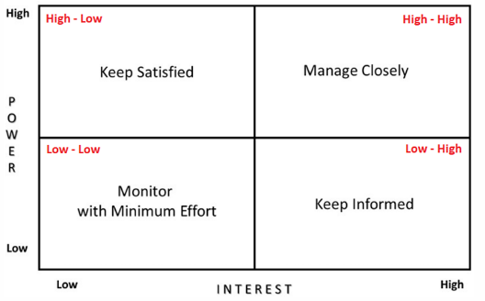
Prioritizing Stakeholders (Power/Interest Grid): Stakeholders are classified by: Power (their ability to influence the project). Interest (how much they care about the project)

Four Quadrants:

High Power – High Interest: Need close management. Most important decision-makers. Example: project sponsor, project manager, team

High Power – Low Interest: Keep them satisfied. They may cause issues if they become unsatisfied. Example: government or regulatory bodies

Low Power – High Interest: Keep them informed. They may feel anxious if not updated. Often very helpful for detailed work. Example: customers or end-users

Low Power – Low Interest: Monitor them with minimal communication. Example: public or uninterested customers. Communicate occasionally (e.g., monthly newsletters)

Levels of Engagement: Analyzing stakeholder engagement involves identifying:
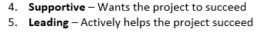
- Unaware – Does not know the project exists
- Resistant – Does not want the project to happen
- Neutral – No strong opinion

Stakeholder Register (with Power/Interest and Engagement Status): This includes: Stakeholder details. Their power/interest category. Their current engagement level. Desired engagement level
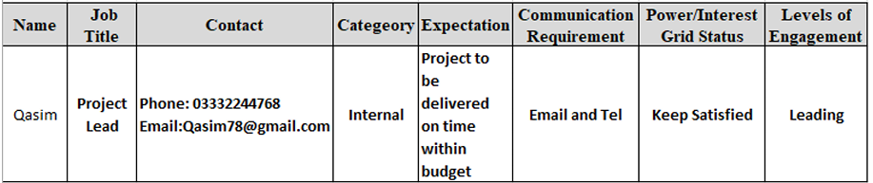

Lecture No. 4 – Software Scope Management
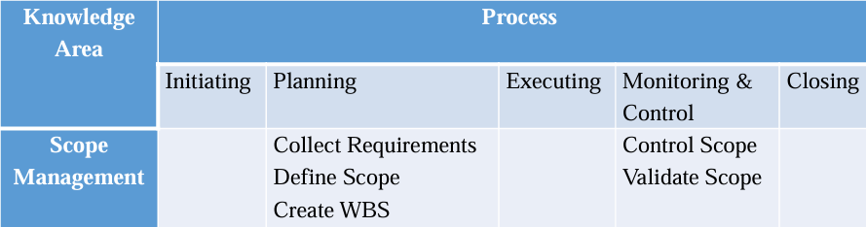

What is Project Scope Management?

Project scope management is the process of identifying and documenting: All project goals, Tasks, Deliverables, Deadlines, Budgets. It is part of the planning stage.

Key Project Objectives
- Meet user requirements: Build the project according to user needs after fully understanding them.
- Meet schedule deadlines: Complete tasks on time as planned in the project schedule.
- Stay within budget: Control costs so the project does not exceed the approved budget.
- Produce quality deliverables: Ensure accuracy, performance, and overall quality of the final outputs.

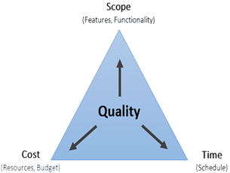
The Triple Constraints of Project Management (Also called: Project Management Triangle, Iron Triangle)
The three constraints are: Scope, Cost, Time. All three are connected — changing one affects the others.

Time Constraint: Includes the schedule, deadlines for each phase, and delivery date.

Scope Constraint: Defines goals, deliverables, features, functions, and all tasks needed.

Cost Constraint: Includes all financial resources: materials, labor, vendors, quality checks, etc.

The 6 Project Constraints: These six constraints are interconnected: Scope, Time, Cost, Quality,

Resources, Risk. Examples: If resources are missing → delivery time increases → cost may increase.

If quality drops → more resources and time needed → cost increases.

If scope creep happens → time, cost, and resources increase → quality may drop → risks increase.

Product Scope: Describes the product/service features and characteristics. Includes physical features (size, material) and functional features (what the product does). Example (bridge): length, width, load capacity.

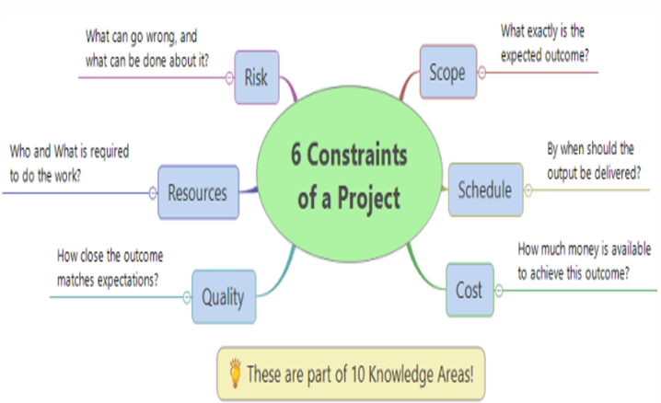
Project Scope: Describes the work required to deliver the product according to the product scope. Example (telephone system): includes software, hardware, training, implementation.

- Project scope completion → measured against project plan.
- Product scope completion → measured against product requirements.
- Both must be aligned so the delivered product matches what was asked for.

1) Collect Requirements Process: Collect Requirements = gathering all requirements from stakeholders.
Requirements help: Define project scope accurately, Reduce negative risks, Increase chances of success, Identify as many needs as possible

Tools & Techniques for Collecting Requirements

Interviews / Expert Interviews: Talking directly to stakeholders (face-to-face, groups, email, video calls).

Focus Groups: Getting opinions from groups of similar stakeholders or experts. Example: meeting with the Marketing department. A moderator usually leads the discussion.

Historical Records: Using information from previous similar projects (product, quality, process requirements).

Facilitated Workshops: Stakeholders come together to define requirements from different perspectives.

Group Creativity Techniques Includes:
- Brainstorming: Generate multiple ideas.
- Nominal Group Technique: Small group brainstorming and voting to prioritize ideas.
- Idea / Mind Mapping: Visual representation of ideas.
- Affinity Diagrams: Grouping ideas into categories.
- Multicriteria Decision Analysis: Ranking ideas based on weighted criteria (risk, cost, uncertainty, etc.)
- Group Decision-Making Techniques: Used when team decisions are required: Unanimity, Majority, Plurality, Dictatorship
- Questionnaires and Surveys: Useful for large audiences. Quick, statistical, effective. Questions may be open or closed.
- Observations: Also known as “job shadowing.”. Watching users perform tasks to understand real workflows.
- Prototypes: Models/mocks of final system. Help stakeholders visualize expected product. Useful for gathering user feedback.
- Benchmarking: Comparing with similar organizations or processes. Identifying industry best practices.
- Context Diagrams: High-level visual maps showing how system interacts with users and external systems.
- Document Analysis: Reviewing business plans, process documents, policies, use cases, etc.

Functional Requirements: Features, behaviors, bug fixes, system actions.

Nonfunctional Requirements (Quality Attributes): Performance, Reliability, Error handling, Ease of use. These describe how the system should behave, not what it does.

Requirements Document: Output of Collect Requirements process includes: Requirements document, Requirements Traceability Matrix (RTM)

Requirements Traceability Matrix: A tool to track each requirement from: Identification, Implementation, Verification

2) Define Scope Process: Define Scope = creating a detailed description of: The project, The product, What is included & what is NOT included. After defining requirements and scope, the PM can: Build the schedule, Estimate the budget
Scope must be balanced against time, cost, and constraints. PM must adjust scope to make the schedule and budget realistic.
Unrealistic budget/schedule is considered the PM’s mistake. Output: Project Scope Statement
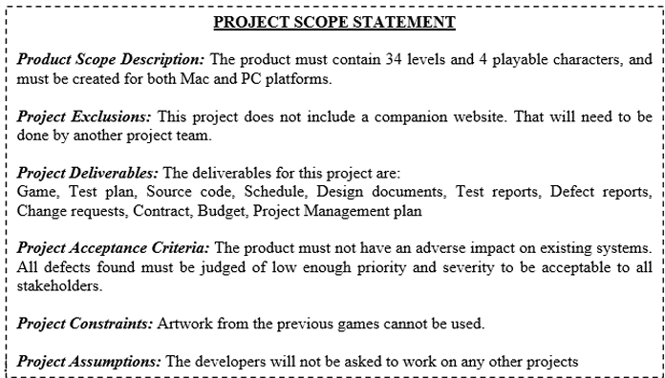

3) Create Work Breakdown Structure (WBS) Process: The most important process in Scope Management.
WBS = breaking down all project work into smaller, manageable tasks. Create WBS process uses outputs from: Collect Requirements, Define Scope.
WBS shows all work needed to complete the project.

4) Control Scope Process
Steps in Change Control (Control Scope):
- A change is needed
- Create a change request
- Get the change approved
- Do variance analysis (compare plan vs actual)
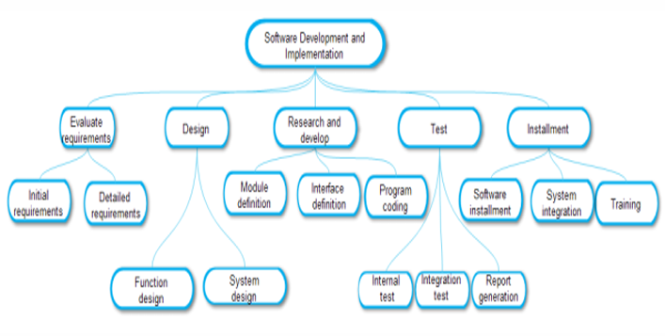
- Re-plan the work
- Create a new baseline

Creating a Change Control System: Because changes always happen, we need a formal system to manage them. A change control system includes: A tool (database or spreadsheet) to record proposed changes. A Change Control Board (CCB) to review and approve changes

About CCB: Can be small or large. More members = slower decisions. All project changes must go to the CCB

Change Request Form: used to submit requested changes.

5) Validate Scope Process: Validate Scope = formal acceptance of deliverables from the customer/sponsor. Happens during Monitoring & Controlling. Done after Quality Control verifies the deliverables. Customer then reviews deliverables to: Accept them Or request changes. Output: Accepted Deliverables

Validate Scope Form: used for customer acceptance.

Lecture 5 – Software Project Scheduling
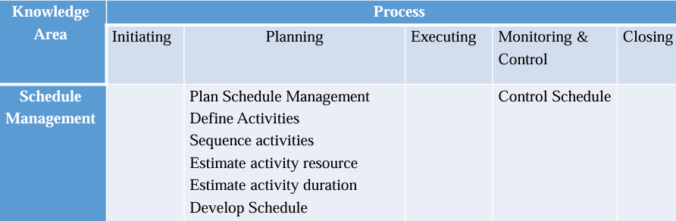

Project Schedule Management: Scheduling is the process of listing all activities, deliverables, and milestones in a project. A schedule includes: start date, finish date, duration, and resources for each activity. Good scheduling is important for effective time management.

Plan Schedule Management Process: This process explains how schedule will be planned, managed, and controlled.
It includes deciding: How to measure performance. How and when to capture data for measuring. How to use that data to keep the project aligned with its schedule baseline. What actions to take when schedule variances happen

Define Activities Process: Uses the Work Breakdown Structure (WBS). Helps identify all activities required to finish the project on time. Ensures nothing important is missed.

Sequence Activities Process: Determines how activities are ordered. Identifies dependencies between tasks: Finish-to-Start (FS) ← most common. Finish-to-Finish (FF). Start-to-Start (SS). Start-to-Finish (SF)
Arranges tasks and milestones in the exact order they must be done. Output: Project Schedule Network Diagram.

Precedence Diagram Method (PDM) / Project Network Diagram: Uses rectangles (nodes) to represent activities. Arrows show dependencies between activities. Also called Activity on Node (AON). Helps show task dependencies and is useful for stakeholder communication.

Types of Dependencies (with examples)
- Finish-to-Start (FS) – A must finish before B starts Example: Web server must run before the SQL database can connect.
- Finish-to-Finish (FF) – Two activities must finish at the same time Example: User acceptance testing and third-party review must end together.
- Start-to-Start (SS) – Two activities must start at the same time Example: Final build and creating online help system should start together.
- Start-to-Finish (SF) – A must start for B to finish (rare) Example: Testing cannot finish until QC department reviews test results.

Critical Path: The longest path through the network. Example critical path: ABDEGIJK. The critical path decides the minimum time in which the project can be completed. Any delay in a critical path activity delays the whole project.

Estimate Activity Duration Process: After estimating activity resources, you estimate how long each activity will take.
Five main techniques:

Expert Estimation: Experts give duration estimates based on experience.

Analogous Estimation: Uses data from previous similar projects. Example: Previous house flooring took 3 months → estimate at least 3 months.

Parametric Estimation Uses formulas or models to compute duration. Example: If 10 ft wall = 1 day → 100 ft wall = 10 days

PERT (Three-Point Estimation): Uses three values: O = Optimistic, M = Most likely, P = Pessimistic: The worst that can happen
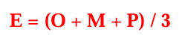
Two formulas:

Triangular Distribution: The simplest three point estimate is the simple average of the three values

Beta (PERT) Distribution: The simplest three point estimate is the simple average of the three values

Reserve Analysis: Add extra time (buffer/contingency reserve) to handle risks.

Develop Schedule Process: Core step of schedule management. Combines all previous scheduling information into the final project schedule / work plan / work schedule.

Control Schedule Process: Happens while project work is ongoing. New information may cause schedule changes. Compare actual progress vs. baseline. Key metrics: Schedule Variance (SV). Schedule Performance Index (SPI). These show how well the project is adhering to schedule.

Steps to Develop a Project Schedule: Identify tasks for the schedule. Determine relationships between tasks. Assign tasks to staff. Estimate effort needed for each task. Consider all variables affecting schedule. Add contingency time (reserves). Identify the critical path. Check for staff over-allocation. Repeat steps 3 and 5–8 until baseline is finalized. Create a Gantt chart for the schedule

Lecture 6 — SOFTWARE PROJECT RISK MANAGEMENT

What is Risk? A risk is an expected loss or a potential problem that might happen in the future. It happens due to lack of information, lack of control, or lack of time. Risk is an uncertain event that can have positive or negative results.

Examples: Driving = risk of accident. Investing = risk of losing money or earning profit.

For every risk, there is some reward, and we must decide if the reward is worth the risk.

What is Software Risk? Software risk = possibility of loss during software development. Loss may include: Higher development cost. Low quality software. Delay in project completion
Why software risks exist? Future is uncertain. Many unknown things cannot be fully planned
Two Types of Software Risks
- Internal (Business) Risks: Under control of the project manager
- External (Pure) Risks: Outside project manager’s control
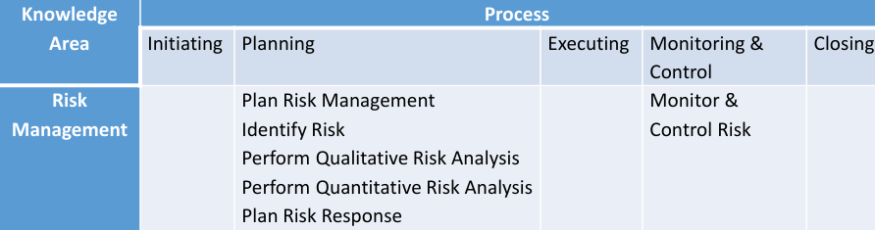

Software Risk Management Processes
- Risk Identification: What risks exist?
- Risk Analysis: Which risks are serious?
- Plan Risk Response: What will we do?
- Risk Monitoring: Did our plan work?

Threats (Negative Risks): Risks that harm the project. Example: Untrained staff → faulty product → more cost/time. Poor communication → low productivity

Opportunities (Positive Risks): Risks that benefit the project. Example: Hiring expert programmer → finish tasks 30% faster

Uncertainty: Happens because of lack of information.

Types of Business Risks: Technology Risks – software/hardware problems, People Risks – issues with team members, Organizational Risks – company environment issues, Tools Risks – issues with development tools, Requirement Risks – changes in customer requirements, Estimation Risks – wrong resource/time estimates

SOFTWARE RISK IDENTIFICATION: To find possible risks: Study problems faced in previous projects. Study the project plan to find weak areas. Conduct brainstorming sessions. Evaluate decisions related to: technical, operational, legal, political, social, internal/external factors

Boehm’s Top 10 Software Risks: Personnel shortfalls. Unrealistic schedules & budgets. Wrong software functions. Wrong user interface. Unnecessary perfectionism. Changing requirements (constant). Outsourced task failures. Outsourced component failures. Real-time performance issues. Technical difficulty too high

SOFTWARE RISK ANALYSIS: Purpose: To prioritize risks based on probability and impact.

Two types: Qualitative Risk Analysis. Quantitative Risk Analysis
Difference: Qualitative = descriptive scale (high/medium/low). Quantitative = numerical scale (mathematical values)

Perform Qualitative Risk Analysis: Estimate Probability and Impact of each risk. Risk Exposure = Probability × Risk Impact.

Risk Impact = cost to project if risk happens. Probability = chance that risk will occur

Perform Quantitative Risk Analysis: Quantitative uses numbers to measure risk. Expected Monetary Value (EMV)
Formula: EMV (or Risk Exposure) = Probability × Impact
Used to calculate: Total project risk. Contingency reserves (extra money needed)

Key Point
- Qualitative = qualities (no numbers)
- Quantitative = quantity (numbers, money)
- Small projects → qualitative. Large projects → quantitative

PLAN RISK RESPONSE

Mitigate: Reduce probability or impact. Example: If a team member may leave, prepare another equally skilled backup.

Transfer: Give risk responsibility to third party. Example: Hire a contractor for installation tasks you cannot handle.

Avoid: Remove the risk completely. Example: If rain risk exists, reschedule outdoor tasks.

Accept: Do nothing—monitor or prepare for it if it occurs. Used for both positive & negative risks.

Difference Between Qualitative & Quantitative Risk Analysis
Qualitative Analysis | Quantitative Analysis
Focuses on all identified risks | Focuses on serious/high-impact risks
No numerical calculations | Uses mathematical calculations
Uses scales (0-5, %, high/low) | Provides cost/time impact
Used for most projects | Used for large/complex projects

Risk Response Plan Example
Risk ID | Name | Response | Risk Generated | Mitigation
1 | Wrong estimation | Accept | Delay | —
2 | Contractor financial issues | Avoid | Delay in commitments | —
3 | Owner financial issues | Avoid | Delay in payments | —
4 | Project delay | Accept | Depression | —
5 | Change in equipment cost | Avoid | Ability to construct | —

SOFTWARE RISK MONITORING: Involves regularly checking top risks. Includes:
- Implementing risk responses
- Tracking identified risks
- Monitoring leftover risks
- Finding new risks
- Checking effectiveness of risk processes

